

**Rapport du projet :**   
Intelligence Artificielle

**Supervised by :**

Mr. Gamouh Hamza

**Professor :**

Mr. Hafidi Hakim

**Group Members :**

Bertal Youssef

Drissi Lahsini Omar

# **Acknowledgements**

Embarking on this project has been a journey of learning, growth, and collaboration. As we present the culmination of our efforts, we wish to extend our deepest gratitude to those who played a pivotal role in shaping its success.

First and foremost, we owe a special debt of gratitude to the incredible community at the International University of Rabat. The unwavering dedication of its faculty and staff has not only equipped us with the skills and knowledge needed to navigate professional challenges but has also instilled in us the confidence to embrace the future.

Our heartfelt appreciation goes to our supervisor, Mr. Gamouh Hamza, whose expertise, mentorship, and accessibility have been a cornerstone of this endeavor. His genuine enthusiasm for this project has inspired us to strive for excellence and has provided guidance when we needed it most.

We also extend our sincere thanks to our esteemed professor, Mr. Hafidi Hakim, for his invaluable oversight and thoughtful feedback throughout this journey. His encouragement and wisdom have been a constant source of motivation.

Together, their collective support, insight, and belief in our potential have been instrumental in bringing this project to fruition. To them, and to all who have supported us along the way, we express our deepest gratitude.

**Summary:**

This document provides an overview of the work accomplished during the integrated project module in the first year of the engineering cycle at the School of Computer Science and Digital Technologies at the International University of Rabat.

Our project, "TrainWise," is an innovative AI-powered fitness application designed to serve as a personal workout assistant. The app helps users identify the muscles they need to target and recommends the most effective exercises to achieve their fitness goals. By merging artificial intelligence with fitness expertise, TrainWise empowers users to train smarter and more efficiently.

The project unfolded over three key phases:  
• In-depth analysis of user fitness goals and problem definition,  
• Design of the application's architecture and intelligent recommendation system,  
• Implementation of key features, such as personalized workout plans and real-time feedback mechanisms.

This report is structured into three main chapters to reflect the project's journey:

* + **Chapter I** lays the groundwork with a comprehensive analysis of user needs and fitness challenges, providing a clear definition of our objectives.
  + **Chapter II** explores the conceptual design, detailing the architecture, algorithms, and technologies that power TrainWise's smart recommendations.
  + **Chapter III** focuses on the practical implementation, describing the integration of core functionalities and user experience enhancements that bring the app to life.

Throughout the development process, we leveraged advanced technologies, tools, and methodologies, building upon knowledge acquired during our academic year. This not only enriched our technical skills but also gave us invaluable insights into creating user-centric applications.

TrainWise represents our commitment to innovation, blending fitness science and technology to create a solution that redefines personal training. This project has not only deepened our technical expertise but also reinforced the importance of developing applications that make a tangible impact on users' lives.

**General Introduction:**

In today’s fitness-focused world, individuals often encounter challenges when trying to design workout routines tailored to their unique needs. Whether aiming to target specific muscle groups or improving overall strength, the overwhelming abundance of information often lacks personalization and clarity. This leads to frustration and inefficiency, as users struggle to find exercises aligned with their fitness goals.

To address these issues, we present **TrainWise**, an AI-powered fitness application. **TrainWise** is designed to provide users with personalized exercise recommendations based on their input, such as identifying the muscle they wish to target or specific fitness objectives they want to achieve. By leveraging state-of-the-art artificial intelligence and a carefully curated database, **TrainWise** simplifies the process of creating effective workout plans, empowering users to train smarter and more effectively.

This report delves into the journey of developing **TrainWise**, focusing on identifying the core problem, designing the solution, and implementing the application.

**Chapter I: Problem Analysis:**

**Problem**

Designing a workout plan that aligns with individual goals is often hindered by several challenges:

1. ***Lack of Personalization:*** Generic exercise recommendations fail to meet specific fitness needs.
2. ***Information Overload:*** The vast array of online resources can overwhelm users, making it difficult to select relevant exercises.
3. ***Limited Guidance:*** Existing tools often lack the intelligence needed to provide precise, actionable recommendations.

**Solution**

TrainWise addresses these issues by employing artificial intelligence to offer tailored exercise suggestions. For example, a user can query, "I want to strengthen my shoulders," and TrainWise will process this request to deliver a list of exercises targeting the desired muscle group, complete with detailed instructions.

**Goals of the Project**

**The primary objectives of TrainWise include:**

* Delivering accurate, real-time recommendations for a variety of fitness goals.
* Creating a user-friendly interface that ensures ease of use for fitness enthusiasts of all levels.
* Designing an architecture that allows scalability, enabling future enhancements like workout tracking and advanced analytics.

**Chapter II: Conceptual Design and Technologies**

***Technologies Used***

1. **Frontend Technologies :**
   * *HTML, CSS, JavaScript:* To build an intuitive and responsive user interface.
2. **Backend Technologies :**
   * *Flask (Python):* For creating a robust and efficient API to handle user requests.
3. **Database Solutions :**
   * *MongoDB:* To store comprehensive exercise data, including target muscles, instructions, and difficulty levels.
   * *ChromaDB:* To implement a vector-based search engine for precise, relevant recommendations.

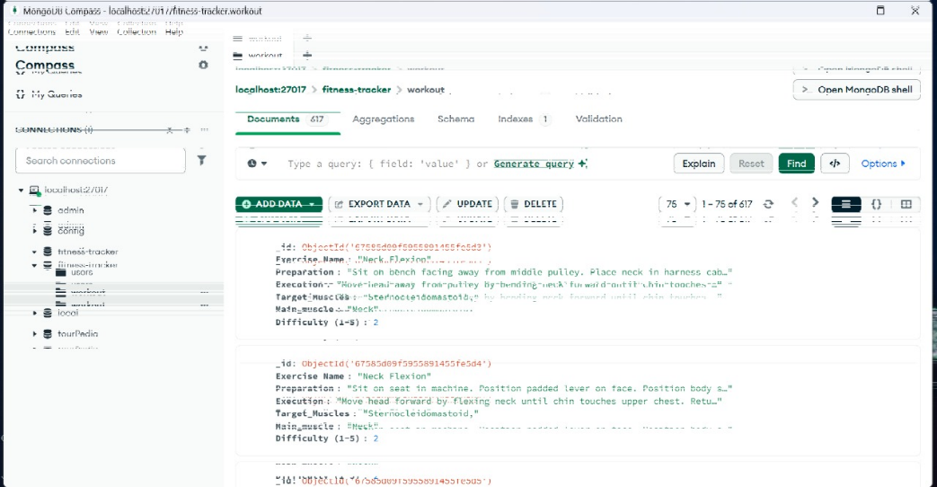

1. **AI Integration:**
   * *Sentence Transformers:* Used to process and analyze user queries by generating embeddings for semantic understanding.

***Architecture***

**The architecture of TrainWise is built on a modular design, consisting of the following components:**

* **Frontend Layer:** Handles user interactions, collects inputs, and displays personalized exercise recommendations.
* **Backend Layer:** Processes user requests, performs database queries, and returns the results.
* **Database Layer:** Stores exercise data and precomputed vector embeddings for efficient searching and retrieval.
* **AI Processing Module:** Analyzes user inputs and finds exercises that match their goals using natural language processing techniques.

**Chapter III: Implementation and Integration**

**Phase 1: Data Preparation**

The foundation of TrainWise lies in its database, which includes:

* Exercise names and categories (e.g., strength, flexibility, endurance).
* Target muscle groups and secondary muscles engaged.
* Difficulty levels, equipment required, and detailed instructions.

**Phase 2: Backend Development**

* Developed APIs using Flask to process user inputs and retrieve matching exercises from the database.
* Integrated Sentence Transformers for analyzing user queries and generating vector embeddings.
* Implemented endpoints for seamless data exchange between the frontend and backend.

**Phase 3: Frontend Development**

* Designed a responsive interface using HTML, CSS, and JavaScript to ensure an engaging user experience.
* Implemented features such as real-time query input, exercise result displays, and filter options for customization.

**Conclusion**

*TrainWise* revolutionizes personal fitness planning by leveraging artificial intelligence to offer tailored exercise recommendations. Its user-centric design and intelligent recommendation system address common challenges faced by fitness enthusiasts, making workout planning more accessible and effective.

Moving forward, the application will be enhanced by expanding the exercise database, integrating features like progress tracking, and incorporating machine learning models to predict user preferences over time. TrainWise stands as a testament to the potential of AI in transforming how we approach fitness and health.